**BCSE497J - Project-I**

**<Title of Project>**

**(Times New Roman 16, Bold, Upper Case, Line spacing 1.5)**

|  |  |
| --- | --- |
| **Reg. No. 1** | **Student Name 1 <Upper case, Bold>** |
| **Reg. No. 2** | **Student Name 2** |
| **Reg. No. 3** | **Student Name 3** |

**(Times New Roman 13, Bold, Upper Case, Line spacing 1.5)**

**(mention the particulars sorted on Register number)**

Under the Supervision of

|  |
| --- |
| Project Guide Name <Bold> |
| Designation |
| School of Computer Science and Engineering (SCOPE) |

**(Line spacing 1.5)**

**B.Tech.**

*in*

**Computer Science and Engineering**

**School of Computer Science and Engineering**



November 2024

**/****** Sample*******/**

**BCSE497J Project-I**

**ROLE OF MACHINE LEARNING AND ARTIFICIAL INTELLIGENCE IN CYBER SCEURITY**

|  |  |
| --- | --- |
| **21BCI00001** | **ABI. S** |
| **21BCI00002** | **BABU. K** |
| **21BCI00003** | **CHANDRU. D** |

**(Mention the particulars sorted on Register number)**

Under the Supervision of

|  |
| --- |
| **Dr. Mohankumar B** |
| Assistant Professor Senior Grade 1 |
| School of Computer Science and Engineering (SCOPE) |

**B.Tech.**

*in*

**Computer Science and Engineering**

**School of Computer Science and Engineering**



November 2024

**ABSTRACT**

**(Times New Roman 14, Bold, Upper Case, Line spacing 1.5)**

<Contents, Times New Roman 12, Line spacing 1.15>

One page and not exceeding 300 words

**/****** Sample*******/**

**ABSTRACT**

The rapid advancement of technology and the increasing reliance on digital systems have made cybersecurity a critical concern for individuals, organizations, and governments. Traditional security measures are no longer sufficient to combat the sophisticated and evolving nature of cyber threats. In this context, the integration of Machine Learning (ML) and Artificial Intelligence (AI) into cybersecurity has emerged as a powerful approach to enhance threat detection, prevention, and response. This project explores the role of ML and AI in strengthening cybersecurity frameworks, focusing on their ability to analyze vast amounts of data, identify patterns, and predict potential security breaches in real-time.

ML algorithms, such as supervised and unsupervised learning, are employed to detect anomalies in network traffic, recognize malicious behavior, and automate the identification of threats, reducing the reliance on human intervention. AI-driven systems, including deep learning models and neural networks, further augment these capabilities by enabling adaptive and proactive defense mechanisms that evolve with emerging threats. The project also examines the challenges associated with implementing ML and AI in cybersecurity, such as the need for large datasets, the risk of adversarial attacks, and the ethical implications of automated decision-making.

Through case studies and experimental analysis, this project demonstrates how ML and AI can be integrated into existing cybersecurity infrastructures to enhance their effectiveness. It also explores future trends and innovations in AI-driven cybersecurity, highlighting the potential for these technologies to transform the field. The findings underscore the importance of ongoing research and development in this area, as well as the need for collaboration between cybersecurity experts, data scientists, and AI researchers to build more resilient and intelligent security systems capable of defending against the ever-evolving landscape of cyber threats.

*Keywords - Artificial Intelligence, Machine Learning, Cybersecurity, Neural Networks, Anomaly Detection.*

**TABLE OF CONTENTS**

**(Times New Roman 14, Bold, Upper Case, Line spacing 1.5)**

<Contents, Times New Roman 12, Line spacing 1.5>

|  |  |  |
| --- | --- | --- |
| **Sl.No** | **Contents** | **Page No.** |
|  | **Abstract < Capitalize Each Word, Bold>** | **i** |
| **1.** | **INTRODUCTION <Uppercase, Bold>** | **1** |
|  | 1.1 Background <Capitalize Each Word, Normal> | **1** |
|  | 1.2 Motivations | **1** |
|  | 1.3 Scope of the Project | **1** |
| **2.** | **PROJECT DESCRIPTION AND GOALS** |  |
|  | 2.1 Literature Review |  |
|  | 2.2 Research Gap |  |
|  | 2.3 Objectives |  |
|  | 2.4 Problem Statement |  |
|  | 2.5 Project Plan |  |
| **3.** | **TECHNICAL SPECIFICATION** |  |
|  | 3.1 Requirements |  |
|  | 3.1.1 Functional |  |
|  | 3.1.2 Non-Functional |  |
|  | 3.2 Feasibility Study |  |
|  | 3.2.1 Technical Feasibility |  |
|  | 3.2.2 Economic Feasibility |  |
|  | 3.2.2 Social Feasibility |  |
|  | 3.3 System Specification |  |
|  | 3.3.1 Hardware Specification |  |
|  | 3.3.2 Software Specification |  |
| **4.** | **DESIGN APPROACH AND DETAILS** |  |
|  | 4.1 System Architecture |  |
|  | 4.2 Design |  |
|  | 4.2.1 Data Flow Diagram |  |
|  | 4.2.2 Use Case Diagram |  |
|  | 4.2.3 Class Diagram |  |
|  | 4.2.4 Sequence Diagram |  |
| **5.** | **REFERENCES** |  |

**1. INTRODUCTION**

**(Times New Roman 14, Bold, Upper Case, Line spacing 1.5)**

<Contents, Times New Roman 12, Line spacing 1.15>

**1.1 Background**

**(Times New Roman 13, Bold, Title Case, Line spacing 1.5)**

<Contents, Times New Roman 12, Line spacing 1.15>

<To provide the reader with the necessary context to understand the project> <Not more than 200 words>

**/** Sample **/**

The rapid digitization of various sectors has led to an unprecedented increase in cyber threats, making cybersecurity a critical concern for organizations, governments, and individuals. Traditional security methods, which rely on predefined rules and signature-based detection, are increasingly inadequate against the sophisticated tactics used by modern cybercriminals. These conventional approaches often fail to detect advanced threats such as ransomware, phishing, advanced persistent threats (APTs), and zero-day exploits, leaving systems vulnerable to attacks.

In response to these challenges, Machine Learning (ML) and Artificial Intelligence (AI) have emerged as powerful tools in the cybersecurity arsenal. These technologies offer the ability to analyze vast amounts of data, identify patterns, and predict potential threats with greater accuracy than traditional methods. By leveraging ML and AI, security systems can adapt to new and evolving threats in real-time, providing a more proactive and dynamic defense.

This project seeks to explore the role of ML and AI in enhancing cybersecurity, focusing on their applications, benefits, and challenges. Through this research, the project aims to contribute to the development of more effective and resilient cybersecurity solutions that can protect against the rapidly evolving landscape of digital threats.

**1.2 Motivation**

**(Times New Roman 13, Bold, Title Case, Line spacing 1.5)**

<Contents, Times New Roman 12, Line spacing 1.15>

< To explain why the project is important and what inspired it> <Not more than 200 words>

**/** Sample **/**

The ever-evolving landscape of cyber threats, coupled with the increasing complexity of attacks, has made traditional cybersecurity measures inadequate. Conventional approaches, which rely on static rules and manual interventions, are often too slow and limited to effectively counter modern threats like ransomware, advanced persistent threats (APTs), and zero-day exploits. As organizations, governments, and individuals become more dependent on digital infrastructure, the stakes for maintaining robust cybersecurity have never been higher. Successful cyberattacks can lead to severe consequences, including financial losses, data breaches, and compromised national security.

This project is motivated by the potential of Machine Learning (ML) and Artificial Intelligence (AI) to revolutionize cybersecurity. Unlike traditional methods, ML and AI can analyze vast datasets, detect anomalies, and predict threats in real-time, enabling a more proactive and adaptive defense. The ability of these technologies to learn from new data and evolve alongside emerging threats offers a significant advantage in protecting against increasingly sophisticated cyberattacks.

The goal of this project is to explore how ML and AI can be integrated into existing cybersecurity frameworks, providing stronger and more intelligent defenses. By addressing the limitations of current practices, this project aims to contribute to the development of more resilient cybersecurity solutions.

**1.3 Scope of the Project**

**(Times New Roman 13, Bold, Title Case, Line spacing 1.5)**

<Contents, Times New Roman 12, Line spacing 1.15>

<To define the boundaries and extent of the project> <Not more than 200 words>

**/** Sample **/**

The scope of this project focuses on exploring the transformative potential of Machine Learning (ML) and Artificial Intelligence (AI) in enhancing cybersecurity. The project will begin by identifying and analyzing current cybersecurity challenges, including emerging threats like advanced persistent threats (APTs), zero-day exploits, and sophisticated malware. By understanding the limitations of traditional security methods, the project aims to highlight areas where AI and ML can provide significant improvements.

The project will involve the development and implementation of ML models for tasks such as anomaly detection, threat classification, and predictive analysis. Additionally, it will explore AI technologies like deep learning and neural networks to create adaptive, real-time security systems. The effectiveness of these models will be tested in both simulated and real-world environments to ensure they offer robust defense mechanisms.

The project also considers the ethical and practical challenges of integrating AI and ML into existing cybersecurity frameworks. This includes addressing concerns about privacy, bias, and the reliability of automated systems. Ultimately, the project aims to contribute to the development of more resilient and intelligent cybersecurity solutions that can effectively respond to the evolving landscape of digital threats.

**2. PROJECT DESCRIPTION AND GOALS**

**(Times New Roman 14, Bold, Upper Case, Line spacing 1.5)**

<Contents, Times New Roman 12, Line spacing 1.15>

**2.1 Literature Review**

**(Times New Roman 13, Bold, Title Case, Line spacing 1.5)**

<Contents, Times New Roman 12, Line spacing 1.15>

< This section of a project report provides a comprehensive overview of existing research, theories, and knowledge relevant to the project>

< Maximum of 50 journal papers are required.>

**2.2 Research Gap**

**(Times New Roman 13, Bold, Title Case, Line spacing 1.5)**

<Contents, Times New Roman 12, Line spacing 1.15>

<To identify the areas or aspects where existing research is lacking or incomplete, which your project aims to address.>

**2.3 Objectives**

**(Times New Roman 13, Bold, Title Case, Line spacing 1.5)**

<Contents, Times New Roman 12, Line spacing 1.15>

< To clearly define what the project aims to achieve. List the primary goals of the project. These should be specific, measurable, achievable, relevant, and time-bound (SMART).>

**2.4 Problem** **Statement**

**(Times New Roman 13, Bold, Title Case, Line spacing 1.5)**

<Contents, Times New Roman 12, Line spacing 1.15>

< Clearly define the issue or challenge that the project will address. This should be specific and focused.>

**2.5** **Project Plan**

**(Times New Roman 13, Bold, Title Case, Line spacing 1.5)**

<Contents, Times New Roman 12, Line spacing 1.15>

<A Gantt chart helps in organizing tasks, setting deadlines, and tracking progress, making it easier to manage the project and communicate the plan to stakeholders.>

**/** Sample **/**

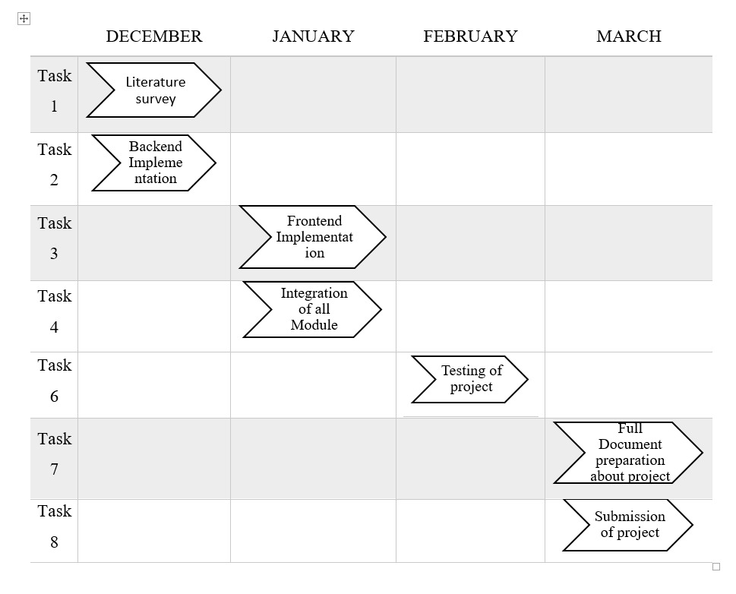

Fig. 1. Gantt chart

**3. TECHNICAL SPECIFICATION**

**(Times New Roman 14, Bold, Upper Case, Line spacing 1.5)**

<Contents, Times New Roman 12, Line spacing 1.15>

**3.1 Requirements**

**(Times New Roman 13, Bold, Title Case, Line spacing 1.5)**

<Contents, Times New Roman 12, Line spacing 1.15>

***3.1.1 Functional***

**(Times New Roman 12, Bold with Italic, Title Case, Line spacing 1.5)**

<Contents, Times New Roman 12, Line spacing 1.15>

**/** Sample **/**

* **Data Collection**: The system should be able to collect and store data from various sources, including network logs, user activity, and external threat databases.
* **Data Preprocessing**: The system should preprocess the collected data to remove noise and irrelevant information.
* **Model Training**: The system should train machine learning models using historical data to identify patterns and anomalies.
* **Real-time Monitoring**: The system should monitor network traffic and user activities in real-time to detect potential security threats.
* **Anomaly Detection**: The system should identify unusual patterns that may indicate a security breach or cyber attack.
* **Alert Generation**: The system should generate alerts for detected threats and provide detailed information for further investigation.
* **User Interface**: The system should provide a user-friendly interface for security analysts to review alerts, analyze data, and manage the system.
* **Reporting**: The system should generate periodic reports summarizing detected threats, system performance, and other relevant metrics.

***3.1.2 Non-Functional***

**(Times New Roman 12, Bold with Italic, Title Case, Line spacing 1.5)**

<Contents, Times New Roman 12, Line spacing 1.15>

**/** Sample **/**

* **Performance**: The system should process and analyze data in real-time with minimal latency.
* **Scalability**: The system should be scalable to handle increasing amounts of data and users without performance degradation.
* **Reliability**: The system should be highly reliable, with minimal downtime and robust error handling.
* **Security**: The system should ensure data integrity and confidentiality, with strong access controls and encryption mechanisms.
* **Usability**: The system should be easy to use, with intuitive navigation and clear documentation.
* **Maintainability**: The system should be easy to maintain and update, with modular components and clear code documentation.
* **Compliance**: The system should comply with relevant industry standards and regulations for cybersecurity and data protection.

**3.2 Feasibility Study**

**(Times New Roman 13, Bold, Title Case, Line spacing 1.5)**

<Contents, Times New Roman 12, Line spacing 1.15>

**/** Sample **/**

***3.2.1 Technical Feasibility***

* **Technology Availability**: The project leverages existing machine learning and AI technologies, which are well-documented and widely used in cybersecurity.
* **Technical Expertise**: The project requires a team with expertise in machine learning, AI, and cybersecurity. Training and hiring the right personnel are crucial.
* **Infrastructure**: Adequate computational resources, such as high-performance servers and cloud computing, are necessary to handle large datasets and complex algorithms.
* **Integration**: The system must integrate seamlessly with existing IT infrastructure and security tools.

***3.2.2 Economic Feasibility***

* **Cost-Benefit Analysis**: The initial investment in technology, infrastructure, and personnel can be high. However, the long-term benefits of enhanced security and reduced risk of cyber attacks can outweigh these costs.
* **Budget**: A detailed budget plan should be created, covering costs for hardware, software, personnel, and ongoing maintenance.
* **Return on Investment (ROI)**: The project should demonstrate a clear ROI by reducing the frequency and impact of security breaches, thereby saving costs associated with data loss, downtime, and regulatory fines.
* **Funding**: Securing funding from stakeholders or external investors is essential for project initiation and sustainability.

***3.2.3 Social Feasibility***

* **User Acceptance**: The system should be user-friendly and provide clear benefits to security analysts and IT staff, ensuring their acceptance and effective use.
* **Training and Support**: Adequate training programs and support resources should be provided to ensure users can effectively operate and maintain the system.
* **Ethical Considerations**: The use of AI and machine learning in cybersecurity should adhere to ethical guidelines, ensuring data privacy and avoiding biases in threat detection.
* **Impact on Workforce**: The project may lead to changes in job roles and responsibilities. It is important to manage these changes through effective communication and support.

**3.2 System Specification**

**(Times New Roman 13, Bold, Title Case, Line spacing 1.5)**

<Contents, Times New Roman 12, Line spacing 1.15>

**/** Sample **/**

***3.2.1 Hardware Specification***

**(Times New Roman 12, Bold with Italic, Title Case, Line spacing 1.5)**

<Contents, Times New Roman 12, Line spacing 1.15>

* **Processor**
* Memory (RAM)
* Storage
* Graphics Processing Unit (GPU)
* Monitor

***3.2.2 Software Specification***

**(Times New Roman 12, Bold with Italic, Title Case, Line spacing 1.5)**

<Contents, Times New Roman 12, Line spacing 1.15>

* Operating System:
* Programming Languages:
* Development Environment:
* Libraries and Frameworks:
* Database:
* Security Tools:

<Please include appropriate hardware & software is required to your project.>

**4. DESIGN APPROACH AND DETAILS**

**(Times New Roman 14, Bold, Upper Case, Line spacing 1.5)**

<Contents, Times New Roman 12, Line spacing 1.15>

**4.1 System Architecture**

**(Times New Roman 13, Bold, Title Case, Line spacing 1.5)**

<Contents, Times New Roman 12, Line spacing 1.15>

**/** Sample **/**

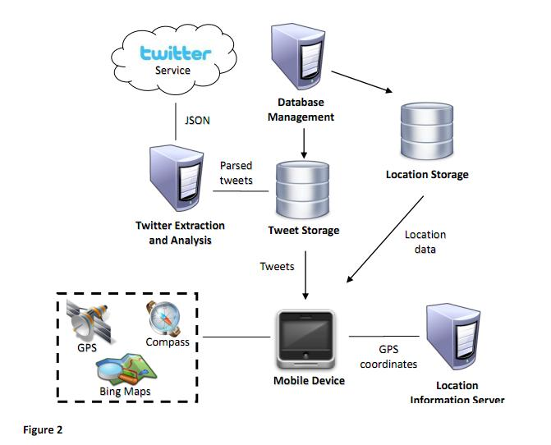

Fig. 2. System Architecture

<Explanation>

**4.2 Design**

**(Times New Roman 13, Bold, Title Case, Line spacing 1.5)**

<Contents, Times New Roman 12, Line spacing 1.15>

***4.2.1 Data Flow Diagram <Mandatory>***

***4.2.2 Use Case Diagram <Mandatory>***

***4.2.3 Class Diagram <Optional>***

***4.2.4 Sequence Diagram*** ***<Optional>***

<Please include whichever diagram is applicable to your project.>

**5. REFERENCES**

**(Times New Roman 14, Bold, Upper Case, Line spacing 1.5)**

<Contents, Times New Roman 12, Line spacing 1.15>

**Weblinks**:

1. https://www.cloudflare.com/under-attack.
2. http://www.thedailybeast.com/articles/2010/12/11/hackers-10-most-famous-attacks-wormsandddos- takedowns.html.

**Journals**: *<IEEE Format>*

1. Apruzzese, Giovanni, Pavel Laskov, Edgardo Montes de Oca, Wissam Mallouli, Luis Brdalo Rapa, Athanasios Vasileios Grammatopoulos, and Fabio Di Franco. "The role of machine learning in cybersecurity." *Digital Threats: Research and Practice,* Vol. 4, No. 1, (2023), pp.1-38. Dasgupta, Dipankar, Zahid Akhtar, and Sajib Sen. "Machine learning in cybersecurity: a comprehensive survey." *The Journal of Defense Modeling and Simulation,* Vol. 19, No. 1, (2022), pp. 57-106.
2. Kumar, Sarvesh, Upasana Gupta, Arvind Kumar Singh, and Avadh Kishore Singh. "Artificial intelligence: revolutionizing cyber security in the digital era." *Journal of Computers, Mechanical and Management*, Vol. 2, No. 3, (2023), pp. 31-42.

**Conference:** *<IEEE Format>*

1. Salih, Azar, Subhi T. Zeebaree, Sadeeq Ameen, Ahmed Alkhyyat, and Hnan M. Shukur. "A survey on the role of artificial intelligence, machine learning and deep learning for cybersecurity attack detection." In *2021 7th International Engineering Conference “Research & Innovation amid Global Pandemic"(IEC)*, pp. 61-66. IEEE, 2021.

**Book**:

1. A.P. Malvino and D.P. Leach – Digital Principles and Applications – Tata McGraw Hill, 2014.